

ATAR course examination
2022 Question/answer booklet

YEAR 11
Physical Education Studies

Student Name: ____________________________________________________________

Number of additional answer booklets used (if applicable):

Time allowed for this paper
Reading time before commencing work: ten minutes
Working time: three hours

Materials required/recommended for this paper
This Question/Answer booklet
Multiple-choice answer sheet
To be provided by the candidate
Standard items: pens (blue/black preferred), pencils (including coloured), sharpener, correction fluid/tape, eraser, ruler, highlighters
Special Items: nil

Important note to candidates
No other items may be taken into the examination room. It is your responsibility to ensure that you do not have any unauthorised material. If you have any unauthorised material with you, hand it to the supervisor before reading any further.

Structure of this paper

Section | Number of questions available | Number of questions to be answered | Suggested working time (minutes) | Marks available | Percentage of written examination
Section One Multiple-choice | 20 | 20 | 30 | 20 | 20
Section Two Short answer | 9 | 9 | 90 | 78 | 50
Section Three Extended answer | 4 | 2 | 60 | 30 | 30
Total |  |  |  |  | 100

Instructions to candidates

- The rules for the conduct of the Western Australian external examinations are detailed in the Year 12 Information Handbook 2021 Sitting this examination implies that you agree to abide by these rules.
- Answer the questions according to the following instructions.
Section One: answer all questions on the separate Multiple-choice answer sheet provided. For each question, shade the box to indicate your answer. Use only a blue or black pen to shade the boxes. If you make a mistake, place a cross through that square, then shade your new answer. Do not erase or use correction fluid/tape. Marks will not be deducted for incorrect answers. No marks will be given if more than one answer is completed for any question.
Section Two: wWrite your answers in this Question/answer booklet. Wherever possible, confine your answers to the line spaces provided.
Section Three: consists of four questions. You must answer two questions. Write your answers in this Question/Answer booklet.

- You must be careful to confine your answers to the specific questions asked and to follow any instructions that are specific to a particular question.
- Supplementary pages for the use of planning/continuing your answer to a question have been provided at the end of this Question/answer booklet. If you use these pages to continue an answer, indicate at the original answer where the answer is continued, i.e. give the page number.

Section One: Multiple-choice 20% (20 marks)
This section has 20 questions. Answer all questions on the separate Multiple-choice answer sheet provided. For each question, shade the box to indicate your answer. Use only blue or black pen to shade the boxes. Do not use erasable or gel pens. If you make a mistake, place a cross through the square, then shade your new answer. Do not erase or use correction fluid/tape. Marks will not be deducted for incorrect answers. No marks will be given if more than one answer is completed for any question.

Suggested working time: 30 minutes
______________________________________________________________________________________

- General motion can be defined as

- motion or translation of a body on a straight trajectory/path.
- motion where the angular rotation of body segments produce linear motion of the body.
- motion of a body in a curved trajectory/path.
- motion of a body in a circular or rotational trajectory/path.

- As physical activity commences, the muscles require additional fuel and oxygen to accommodate the increased demands for energy. The body achieves this by sending more blood to the working muscles/tissues by increasing cardiac output. Which of the following is true of cardiac output?

- an increase in cardiac output is the result of an increase in stroke volume and beats per minute (bpm) when exercising
- cardiac output is the amount of blood circulated by the heart per beat
- cardiac output creates a decrease in blood pressure
- cardiac output will decrease as a result of long-term adaptations to training

- A human leg extends from ball and socket joint at the pelvis and comprises of the following bones:

- tibia, fibula, radius, patella
- clavicle, scapula, fibula, femur
- humerus, patella, tibia, fibula
- tibia, fibula, patella, femur

- There is a relationship said to exist between arousal levels and optimal performance, this can be explained by

- the Inverted U Hypothesis, which states that performance increases with arousal to a certain point, after which it can cause performance to decline.
- Nideffer’s Model which states that arousal and performance rely on the ability to attend to relevant cues.
- the Inverted U Hypothesis, which states that performance decreases with arousal to a certain point, after which it can cause performance to increase.
- Nideffer’s Model which states that a broad focus will increase arousal to an optimal point, which will result in an increase in performance.

- A tennis coach is attempting to develop the accuracy of their player’s forehand drive. They place a target area on the court to help the player direct the shot. This is an example of a

- verbal cue.
- proprioceptive cue.
- kinaesthetic cue.
- visual cue.

- Identify the correct labels:

- A – deltoid, B – gastrocnemius, C – radius, D – tarsals
- A – pectoral, B – soleus, C – ulna, D – metatarsals
- A – trapezius, B – tibialis anterior, C- ulna, D – tarsals
- A – pectoral, B - tibialis anterior, C – radius, D - metatarsals
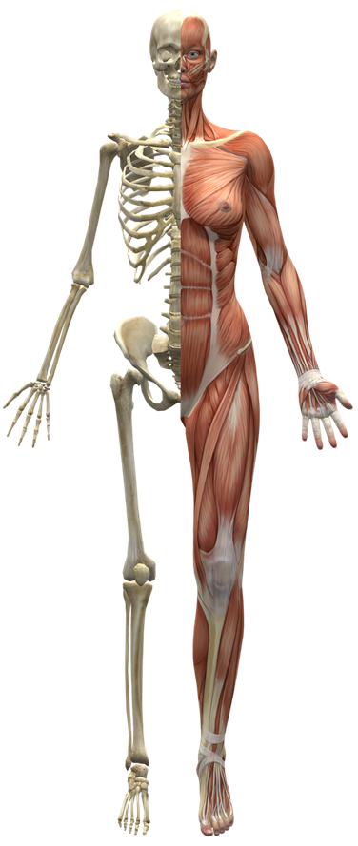
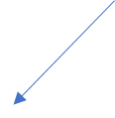
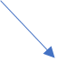
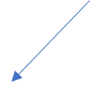
A
D
C
B

- A golf swing is an example of a

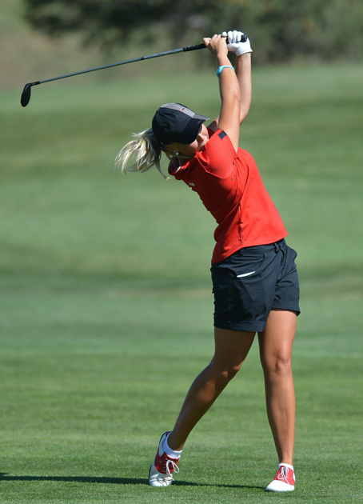
- discrete skill.
- serial skill.
- continuous skill.
- fine motor skill.

- Sasha has started going to the gym three times a week and has removed all processed ‘junk’ food from her diet. As a result of these lifestyle changes and positive goal setting, Sasha has increased energy and is feeling happier and healthier than ever. This feeling helps her to stay motivated to continue exercising and eating a healthy diet. This is an example of

- extrinsic motivation.
- the zone of optimum functioning.
- intrinsic motivation.
- arousal relationship.

- When the height of release of a projectile is greater than the landing point, the optimal projection or release angle will be

- greater than 45 degrees.
- lower than 45 degrees.
- equal to the height.
- dependent on the weather conditions.

- A pre-season training session involves football players taking part in a modified form of continuous training, involving regular changes of pace in response to naturally occurring obstacles, such as hills. This training type is defined as

- resistance training.
- circuit training.
- Fartlek.
- plyometrics.

- The movement below involves moving the leg up (1) and then back down (2) to complete one repetition. Name the movement types demonstrated.

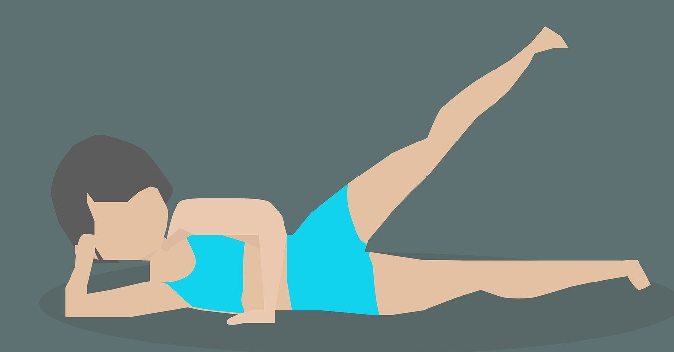
2
1

- abduction (1), adduction (2)
- adduction (1), abduction (2)
- extension (1), flexion (2)
- flexion (1), extension (2)

- To create improvements in sporting performance, all training programs should adhere to the principle of progressive overload. Overloading the body during training can be achieved by varying three factors:

- specificity, intensity, reversibility
- intensity, frequency, duration
- intensity, duration, recovery
- time, frequency, specificity

- A gymnast receives immediate internal feedback regarding their balance in a handstand as soon as they execute it. This type of feedback during performance is called

- verbal feedback.
- extrinsic feedback.
- concurrent feedback.
- terminal feedback.

- When executing a smash in badminton, the coach encourages the player to contact the shuttle at its highest point. What would be the most relevant rationale behind this instruction?

- to give the player more time to execute the shot and move into a defensive position quickly
- to give the player an opportunity to impart greater linear velocity onto the shuttle as a result of greater angular motion at the distal end of the racquet
- to give the player an opportunity to apply Newton’s third law of motion and create greater distance on the shuttle
- to trick the opposition into thinking the player is going to do a drop shot instead of a smash to easily win the point
- The gaseous exchange occurs during respiration to allow oxygen to be exchanged for the carbon dioxide which has been returned from the body. Where does this exchange take place?

- in the nasal cavity, whilst the cilia filter out the unwanted waste gas
- at the base of the trachea, in the two major branches of the bronchi
- in the diaphragm as it contracts and relaxes to create pressure differential to allow the exchange to take place
- in the microscopic air sacs called alveoli, at the end of the bronchioles

- The stationary bridge pose, as shown in the photograph below, is an excellent strengthening exercise for the posterior muscles of the body. This category of resistance training types would be

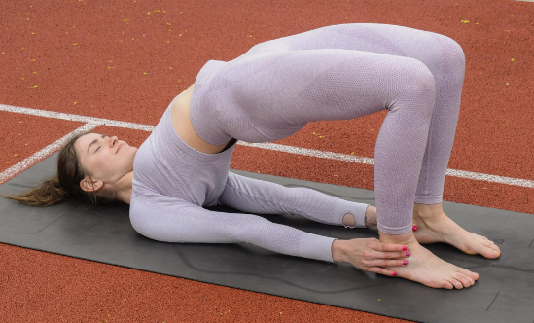
- isometric.
- isokinetic.
- isotonic.
- isogeneic.

- Carbohydrates, fats and proteins play an important role in the production of ATP production. Which of the following statements is/are true?

- carbohydrates are the primary fuel sources and are stored in the muscles as glycogen
- protein is used as a fuel source in extreme circumstances, for example in ultra-marathons
- carbohydrates can last for over four hours without replenishing
- a and b

- With reference to muscle contraction, which of the following statements is the most accurate?

- attachment points allow a muscle to push and pull
- muscle attachment at the stationary end of the bone is called the origin of a muscle
- muscle attachment at the moving end of the bone is called the origin of a muscle
- muscle attachment at the stationary end of the bone is called the insertion point of a muscle

- The aim of javelin throw is to maximise distance. Throwers achieve this by applying maximum force over the longest period of time. This can be achieved through

- perfectly timed simultaneous movement
- keeping the centre of gravity within the base of support
- perfectly timed sequential movement
- increasing rotational inertia

- Goal setting is an important process in performance and maintaining motivation. Young, novice performers would most likely benefit from

- staying focused on outcome goals only
- setting ambitious long-term goals to maintain motivation
- setting realistic short-term goals which are reviewed regularly
- working on the same goals for the duration of the season
End of Section One
Section Two: Short answer 50% (78 marks)

This section has six questions. Answer all questions. Write your answers in the space provided.
Use blue or black pen (not pencil) for this section.
Supplementary pages for planning/continuing your answers to questions are provided at the end of this Question/Answer booklet. If you use these pages to continue an answer, indicate at the original answer where the answer is continued, i.e. give the page number.
Suggested working time: 70 minutes.
______________________________________________________________________________________
Question 21 11 marks

The photographs below show two different techniques of headstand. The biomechanical principle of balance is crucial when performing these postures.

- Compare the two headstand techniques with reference to two factors that enable stability to be maintained. Identify which headstand would be easier to perform and provide a reason. (4 marks)
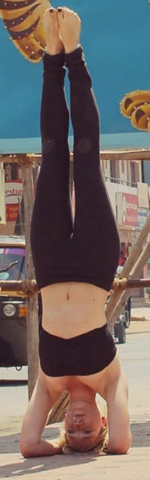
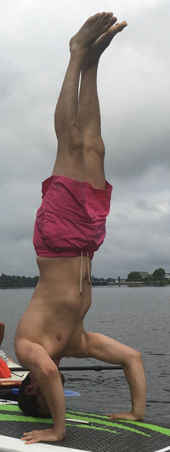

Headstand A Headstand B
__________________________________________________________________________________________________________________________________________________________________________________________________________________________________________________________________________________________________________________________________________________________________________________________________________________________________________________________________________________________________________________________________________________________________________________________________________________________
- Executing a headstand requires focus and concentration. One model that explains attentional focus is Nideffer’s Model of Attention. Complete the diagram below to include

- labels for axis A and B
- labels for the four attentional styles (C, D, E and F)
- label the position of the attentional style most suitable for the headstand
(7 marks)

D __________

C __________
E __________
A __________

F __________
B __________

Question 22 13 marks

Below is an image of a soccer player preparing to kick a ball.
- Label the two muscles labelled A and B in the box provided. (2 marks)
- Label the insertion point and origin point of muscle A on the diagram. (2 marks)
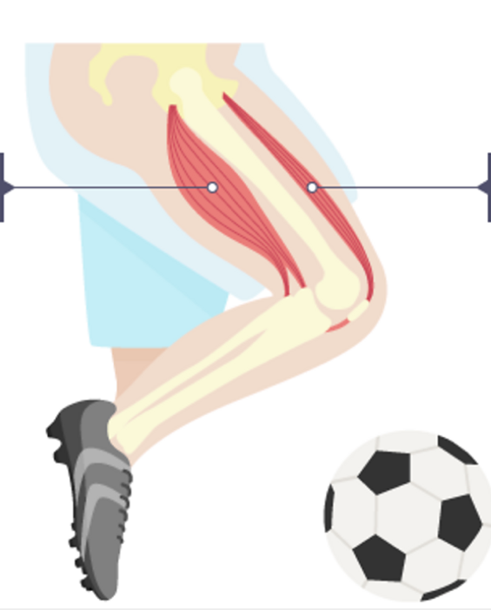
B ____________________
A ____________________

- Muscles work in pairs to create movement. Define the role of the origin and the insertion and explain how the muscles on the front and back of the thigh work together to create movement to flex the knee in preparation to strike the ball. (6 marks)
________________________________________________________________________________________________________________________________________________________________________________________________________________________________________________________________________________________________________________________________________________________________________________________________________________________________________________________________________________________________________________________________________________________________________________________________________________________________________________________________________________________________________________
- The soccer coach leads the players through an intense session of rapid muscle lengthening/shortening duration.

Name the training type being demonstrated by the players in the photograph below and identify which muscle fibre type this kind of training would benefit. Provide one characteristic of this muscle fibre type that supports your answer. (3 marks)
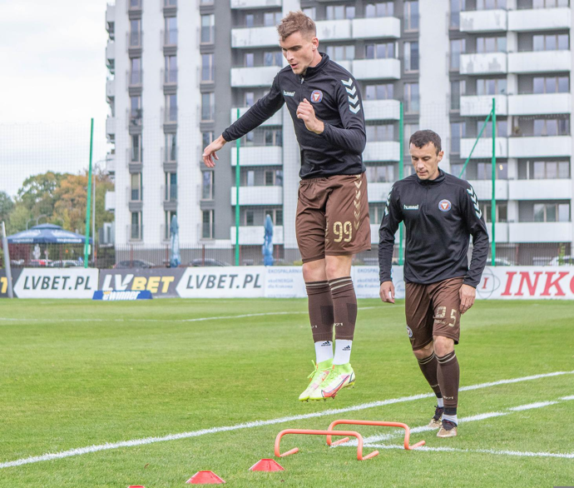

________________________________________________________________________________________________________________________________________________________________________________________________________________________________________________________________________________________________________________________________________________________
Question 23 11 marks

A gymnastic coach encourages their gymnast to increase their height of release by using a mini trampoline when learning a somersault.

- With reference to optimal projection, explain the rationale behind this recommendation by the coach and why it may be of benefit to the gymnast. (3 marks)

________________________________________________________________________________________________________________________________________________________________________________________________________________________________________________________________________________________________________________________________________________________

- Apart from height of release. Name and define the two other factors that contribute to the flight path (parabolic trajectory) of a projectile, which would also be considered by the coach. (4 marks)
____________________________________________________________________________________________________________________________________________________________________________________________________________________________________________________________________________________________________________________________________________________________________________________________________________________________________________________________________________________________________________________________________

- The gymnast struggles with pre-competition nerves each time they get ready to perform their floor routine. The impact of stress and nerves negatively affects their physical performance and self-confidence.

Name two of the most relevant mental skills strategies which this gymnast could use pre-performance to
- decrease the physical symptoms of nerves e.g. shaking
- increase self-confidence prior to performance.

For each strategy provide a relevant example of how the gymnast could apply this technique. (4 marks)
______________________________________________________________________________________________________________________________________________________________________________________________________________________________________________________________________________________________________________________________________________________________________________________________________________________________________________

Question 24 15 marks
When getting ready to receive a serve in tennis, a player is processing a considerable amount of information in preparing to perform the skill.
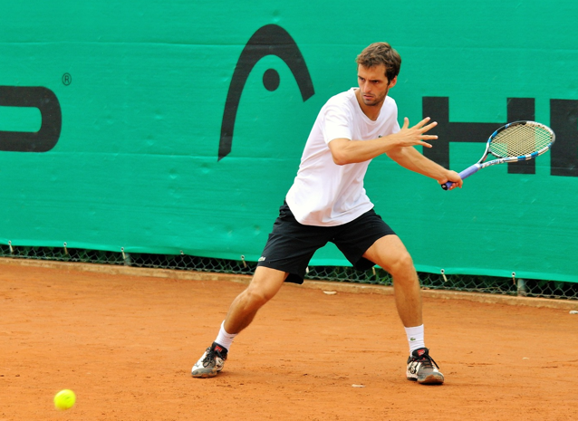

- Draw and label a diagram in the space below which represents the four phases of information processing that could be used to explain the process that the tennis player is experiencing when receiving a serve. (4 marks)

- For each phase, describe one example which could be applied to the tennis player receiving the serve. (8 marks)
________________________________________________________________________________________________________________________________________________________________________________________________________________________________________________________________________________________________________________________________________________________________________________________________________________________________________________________________________________________________________________________________________________________________________________________________________________________________________________________________________________________________________________
- Tennis matches involve high intensity physical activity often over a prolonged period. During a rest break between sets a player decides to eat a banana and consumes a sports drink. With reference to energy sources, explain why a player may choose this nutritional strategy. (3 marks)
__________________________________________________________________________________________________________________________________________________________________________________________________________________________________________________________________
Question 25 17 marks

Athletes rely on the efficiency of their circulatory system to carry oxygen and nutrients around the body to all the cells, whilst removing waste products and carbon dioxide.

- Blood is the main fluid in the circulatory system. The blood is made up of four main components. Identify the four components found in the blood and outline their main function. (8 marks)
________________________________________________________________________________________________________________________________________________________________________________________________________________________________________________________________________________________________________________________________________________________________________________________________________________________________________________________________________________________________________________________________________________________________________________________________________________________________________________________________________________________________________________
- Complete the following by identifying the correct reference or by providing a definition. (6 marks)

- Carry blood to the heart ________________________________________________

- The largest artery in the body ___________________________________________

- Responsible for carrying deoxygenated blood from the heart to each lung ____________________________________________________________________________
- Ventricles ____________________________________________________________________________
- Atria
____________________________________________________________________________
- Stroke volume
____________________________________________________________________________

- As an athlete begins their training session, several immediate, physiological responses occur in the body and the athlete will begin to experience an increase in body temperature. Account for the increase in temperature experienced by the athlete and describe how the body prevents overheating. (3 marks)
________________________________________________________________________________________________________________________________________________________________________________________________________________________________________________________________________________________________________________________________________________________
Question 26 11 marks

A long-distance runner will require very different components of fitness than a 50m freestyle swimmer.

- Identify and define the two components of fitness that would be the most important for the long-distance runner and two components of fitness that would be the most important for the 50m swimmer (use different components for each athlete). (8 marks)

________________________________________________________________________________________________________________________________________________________________________________________________________________________________________________________________________________________________________________________________________________________________________________________________________________________________________________________________________________________________________________________________________________________________________________________________________________________________________________________________________________________________________________________________________________________________________________________________________________________________________________________________________________________________________________________________________________________________________________________________________________________________________________________________________
- For either the long-distance runner or 50m swimmer, choose one of their main components of fitness and justify which training type would be most beneficial for them to include in their training program. (3 marks)
________________________________________________________________________________________________________________________________________________________________________________________________________________________________________________________________________________________________________________________________________________________

End of Section Two
Section Three: Extended answer 30% (30 marks)
This section contains four questions. You must answer two questions. Write your answer in the spaces provided.
Supplementary pages for planning/continuing your answers to questions are provided at the end of this Question/ Answer booklet. If you use these pages to continue an answer, indicate at the original answer where the answer is continued, i/e. give the page number.
Suggested working time: 50 minutes
______________________________________________________________________________________
Question 27 15 marks
Netball is a fast-paced game that requires multiple high intensity sprints and drives to receive the ball, followed by limited recovery between these bouts of effort, where lower intensity movement or rest takes place.
With reference to the energy system continuum, identify which energy system will predominantly fuel the netball player during these high intensity movements on the ball, provide justification for your choice. Compare the contribution of each energy system during a game of netball, outlining fuel source, speed of energy supply, oxygen requirements, duration of the energy system and give a relevant example of when a player may use this energy system in a game situation. (15 marks)

________________________________________________________________________________________________________________________________________________________________________________________________________________________________________________________________________________________________________________________________________________________________________________________________________________________________________________________________________________________________________________________________________________________________________________________________________________________________________________________________________________________________________________________________________________________________________________________________________________________________________________________________________________________________________________________________________________________________________________________________________________________________________________________________________________________________________________________________________________________________________________________________________________________________________________________________________________________________________________________________________________________________________________________________________________________________________________________________________________________________________________________________________________________________________________________________________________________________________________________________________________________________________________________________________________________________________________________________________________________________________________________________________________________________________________________________________________________________________________________________________________________________________________________________________________________________________________________________________________________________________________________________________________________________________________________________________________________________________________________________________________________________________________________________________________________________________________________________________________________________________________________________________________________________________________________________________________________________________________________________________________________________________________________________________________________________________________________________________________________________________________________________________________________________________________________________________________________________________________________________________________________________________________________________________________________________________________________________________________________________________________________________________________________________________________________________________________________________________________________________________________________________________________________________________________________________________________________________________________________________________________________________________________________________________________________________________________________________________________________________________________________________________________________________________________________________________________________________________________________________________________________________________________________________________________________________________________________________________________________________________________________________________________________________________________________________________________________________________________________________________________________________________________________________________________________________________________________________________________________________________________________________________________________________________________________________________________________________________________________________________________________________________________________________________________________________________________________________________________________
Question 28 15 marks
The photograph below shows a highly skilled basketball player on a fast break down the court. The player is proficient in executing the skill of dribbling, whilst being able to attend to additional cues surrounding him during the game.
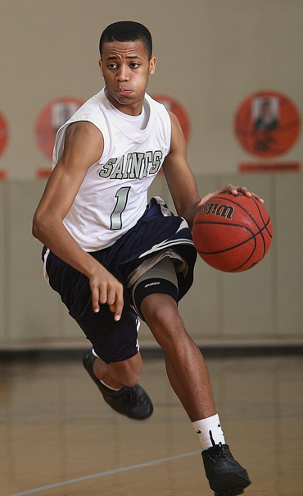

Aware of his teammates
Proficient dribbling skills
Aware of the opposing team

Name and outline the three phases of the Fitts and Posner Model of motor learning that this player would have progressed through to reach his current level of proficiency. State two performance characteristics which would be evident at each stage of learning and outline the type of feedback which would optimise learning at each stage. (15 marks)
__________________________________________________________________________________________________________________________________________________________________________________________________________________________________________________________________________________________________________________________________________________________________________________________________________________________________________________________________________________________________________________________________________________________________________________________________________________________________________________________________________________________________________________________________________________________________________________________________________________________________________________________________________________________________________________________________________________________________________________________________________________________________________________________________________________________________________________________________________________________________________________________________________________________________________________________________________________________________________________________________________________________________________________________________________________________________________________________________________________________________________________________________________________________________________________________________________________________________________________________________________________________________________________________________________________________________________________________________________________________________________________________________________________________________________________________________________________________________________________________________________________________________________________________________________________________________________________________________________________________________________________________________________________________________________________________________________________________________________________________________________________________________________________________________________________________________________________________________________________________________________________________________________________________________________________________________________________________________________________________________________________________________________________________________________________________________________________________________________________________________________________________________________________________________________________________________________________________________________________________________________________________________________________________________________________________________________________________________________________________________________________________________________________________________________________________________________________________________________________________________________________________________________________________________________________________________________________________________________________________________________________________________________________________________________________________________________________________________________________________________________________________________________________________________________________________________________________________________________________________________________________________________________________________________________________________________________________________________________________________________________________________________________________________________________________________________________________________________________________________________________________________________________________________________________________________________________________________________________________________________________________________________________________________________________________________________________________________________________________________________________________________________________________________________
Question 29 15 marks
Athletes competing in the steeple chase undergo vigorous training to meet the demands of this gruelling race. Improvements in performance are the product of long-term physiological adaptations over time.
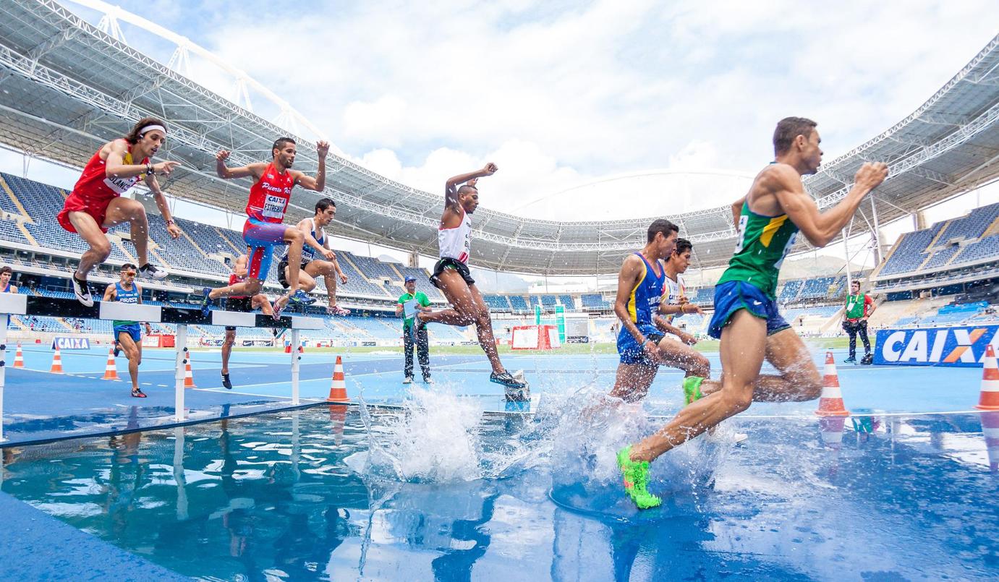

- One adaptation the athletes would experience is more efficient respiration. This would occur in response to an increase in breathing volume and optimisation of the breathing muscles responsible for inspiration and expiration. Explain the mechanics of breathing during inspiration and expiration, referring to the role of diaphragm and the process that allows airflow in and out of the lungs.
(7 marks)

__________________________________________________________________________________________________________________________________________________________________________________________________________________________________________________________________________________________________________________________________________________________________________________________________________________________________________________________________________________________________________________________________________________________________________________________________________________________________________________________________________________________________________________________________________________________________________________________________________________________________________________________________________________________________________________________________________________________________________________
- Apart from the long-term adaptation of more efficient respiration, identify four other long-term adaptations of training on the cardiorespiratory system that these athletes may experience over time and outline how each adaptation is of physiological benefit to the athlete. (8 marks)
__________________________________________________________________________________________________________________________________________________________________________________________________________________________________________________________________________________________________________________________________________________________________________________________________________________________________________________________________________________________________________________________________________________________________________________________________________________________________________________________________________________________________________________________________________________________________________________________________________________________________________________________________________________________________________________________________________________________________________________________________________________________________________________________________________________________________________________________________________________________________________________________________________________________________________________________________________________________________________________________________________________________________________________________________________________________________________________________________________________________________________________________________________________________________________________________________________________________________________________________________________________________________________________________________________________________________________________________________________________________________________________________________________________________________________________________________________________________________________________________________________________________________________________________________________________________________________________________________________________________________________________________________________________________________________________________________________________________________________________________________________________________________________________________________________________________________________________________________________________________________________________________________________________________________________________________________________________________________________________________________________________________________________________________________________________________________________
Question 30 15 marks
A high jumper changes their movement during the approach phase from a horizontal motion to a vertical motion by applying a greater downward force on the last step before take-off. The rationale behind force application can be linked to Newton’s First, Second and Third Law of motion.
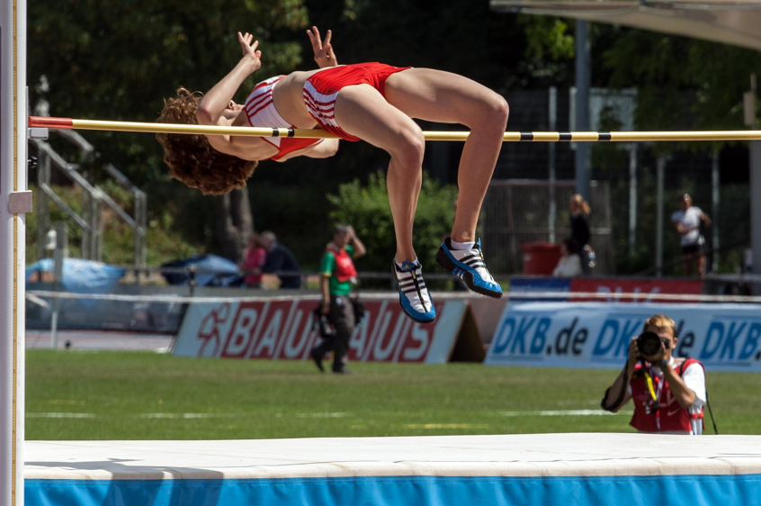

- Define Newton’s First, Second and Third Law. With reference to the Newton’s First and Third law, explain how each law can be applied to the high jumper during run-up and take off. (7 marks)
________________________________________________________________________________________________________________________________________________________________________________________________________________________________________________________________________________________________________________________________________________________________________________________________________________________________________________________________________________________________________________________________________________________________________________________________________________________________________________________________________________________________________________________________________________________________________________________________________________________________________________________________________________________________________________________________________________________________________________________________________________________________________________________________________________________________________________________________________________________________________________________________________________________________________________________________________________________________________________________________________________________________________________________________________________________________
- Arousal levels during performance are an important component in sporting competitions. High jump competitors often have to wait for long periods of time between jumps, which can affect arousal regulation and performance levels.

Name and explain the relationship between arousal and performance, draw and label a diagram to support your discussion, indicating the point of optimal arousal for the high jumper. (8 marks)
__________________________________________________________________________________________________________________________________________________________________________________________________________________________________________________________________________________________________________________________________________________________________________________________________________________________________________________________________________________________________________________________________________________________________________________________________________________________________________________________________________________________________________________________________________________________________________________________________________________________________________________________________________________________________________________________________________________________________________________________________________________________________________________________________________________________________________________________________________________________________________________________________________________________________________________________________________________________________________________________________________________________________________________________________________________________________________________________________________________________________________________________________________________________________________________________________________________________________________________________________________________________________________________________________________________________________________________________________________________________________________________________________________________________________________________________________________________________________________________________________________________________________________________________________________________________________________________________________________________________________________________________________________________________________________________________________________________________________________________________________________________________________________________________________________________
End of questions

References
Question 6
https://pixabay.com/illustrations/muscles-skeleton-half-body-2277447/
Question 7
https://pixabay.com/photos/golf-swing-texas-tech-sports-552906/
Question 11
https://pixabay.com/illustrations/exercise-side-lying-leg-raises-woman-2180074/
Question 16
https://pixabay.com/photos/yoga-meditation-fitness-health-6886045/
Question 21
https://pixabay.com/photos/headstand-sirsasana-yoga-ashtanga-389697/
https://pixabay.com/photos/yoga-paddleboard-paddleboarding-1634439/
Question 22
https://www.bbc.co.uk/bitesize/topics/znyycdm/articles/zd7yydm
Question 22
https://pixabay.com/photos/training-players-soccer-sport-game-6716071/
Question 24
https://pixabay.com/photos/tennis-head-ramos-vinolas-clay-934841/
Question 28
https://pixabay.com/photos/basketball-player-athlete-game-1642384/
Question 29
https://pixabay.com/photos/action-athletes-competition-hurdles-1834465/
Question 30
https://pixabay.com/photos/sports-athletics-high-jump-659592/

